**Test cases, suites, scripts and scenarios**

**Test Scenario vs Test Case:**

|  |  |
| --- | --- |
| **TEST SCENARIO:** | **TEST CASE:** |
| **High Level documentation** | **Low Level documentation** (detailed) |
| **\*A short sentence** | **\*Consists of multiple components**, which have their own multiple steps |
| **Does not have data** that you need to enter to an application **to test** | **Has all exact data** that you need to enter to the application **to test it** |
| It only tells you **what to test** | Tells you **how to test** |
| **Derived from the Requirement** | **Derived from Test Scenarios** |
| **\***Consists one line what to test | **\***Consists of serial number, test scenarios, preconditions, expected outcome, actual outcome, wether its automated or not, etc. |
| With the help of TS, we validate the functionality of an application | Validate wether the test scenario is correct or not |
| Less time to prepare | Requires more time to prepare |
| Less resources | More resources |

**\*:**

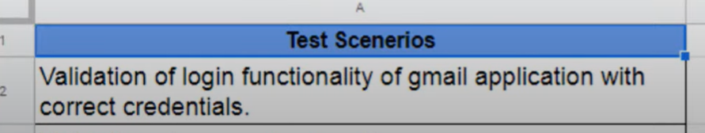

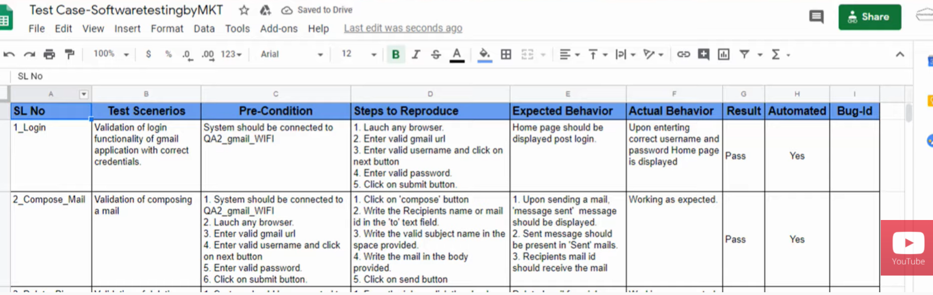

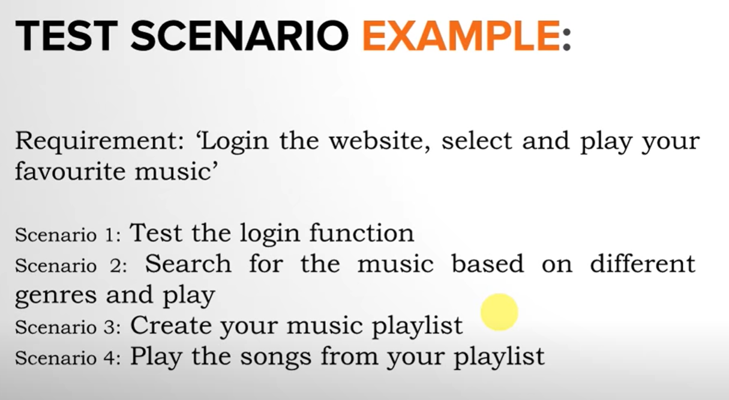

**Reference:** [**https://www.youtube.com/watch?v=Ix483GoBXs4&ab_channel=SoftwaretestingbyMKT**](https://www.youtube.com/watch?v=Ix483GoBXs4&ab_channel=SoftwaretestingbyMKT)

**A test case**, in software testing, is **a set of conditions under which a tester will determine whether an application**, software system or one of its features **is working as it was developed** and expected to do.

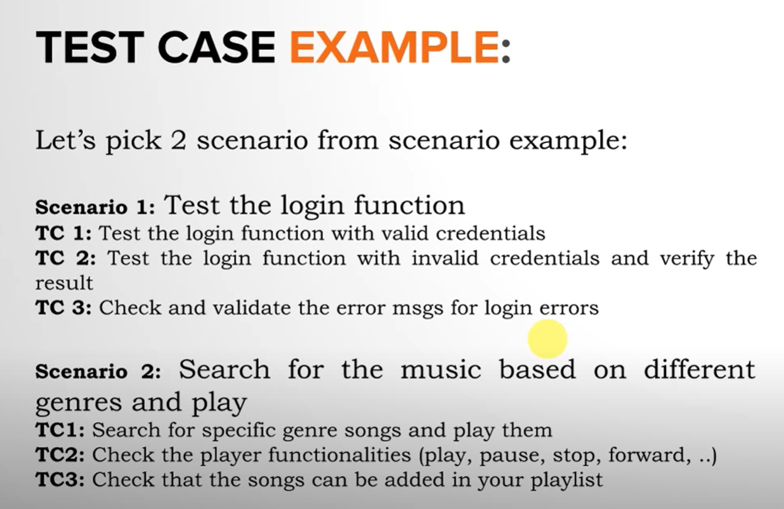

**Test Case writing:**

1. **Step 1: Test Case ID. ...**
2. **Step 2: Test Description. ...**
3. **Step 3: Assumptions and Pre-Conditions. ...**
4. **Step 4: Test Data. ...**
5. **Step 5: Steps to be Executed. ...**
6. **Step 6: Expected Result. ...**
7. **Step 7: Actual Result and Post-Conditions. ...**
8. **Step 8: Pass/Fail.**

**Test Suites & Cases:**

**Test Cases** contain the details and steps that a tester will need to perform to verify a certain behavior.

**Test Suites** – a logical collection of one or multiple test cases (Logical, because test cases are grouped into categories).

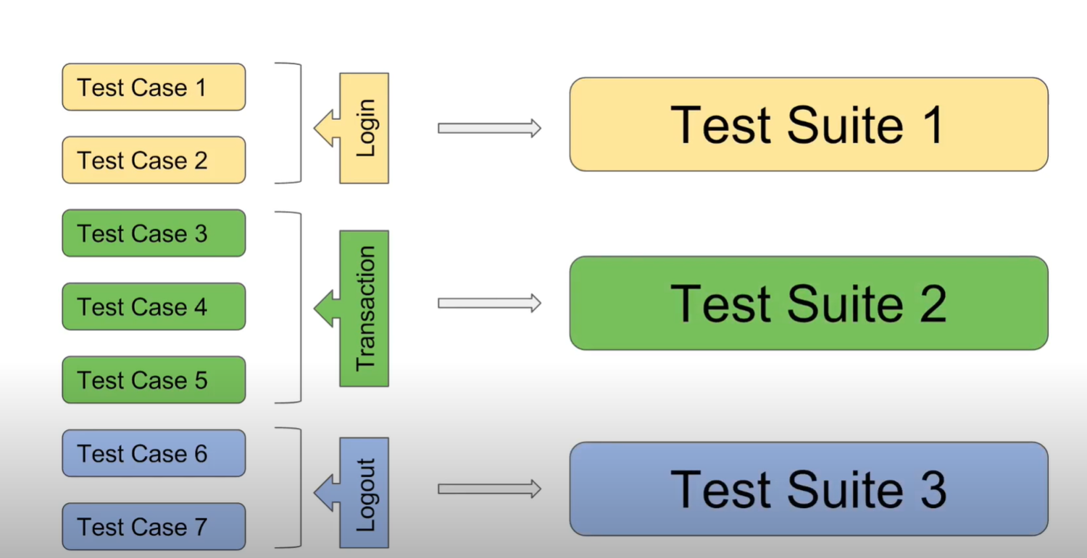

**Test Suites can:**

* Often be run automatically
* Run periodically
* Nightly
* On every commit

Test suite **goal** is to show that some software under test has some desired properties, mainly, passing all the tests.

**Features of Test Suites:**

* **Small, feature specific tests.** To have a lot of unit tests or at least feature-specific tests that are small tests that exercise very specialised behaviors. E.g.: developing a web browser, testing that each HTML elements render correctly.
* **Large, realistic inputs.** E.g.: if we‘re testing a microprocessor, booting up Linux and running it for a couple of hours. Purpose – realistic streches on the system and to exercise a lot of features and combination.
* **Regression tests** - any input that caused some previous version to fail.

We want to make sure that the software in your test doesn‘t regress/doesn‘t go back into a state in which it fails on a bug that we already fixed.

* Usually **not a random tester –** **test suite is supposed to be predictable**, as a random tester may introduce some new test cases that we haven‘t seen before. For this reason, random testing is often a seperate activity.

**Regression testing** is a **software testing practice that ensures an application still functions as expected after any code changes**, updates, or improvements.

**Reference:** <https://www.youtube.com/watch?v=dwQCVHeYDHo&ab_channel=Udacity>

Extra Reference: <https://www.youtube.com/watch?v=dniwCknLG4s&ab_channel=AutomationStepbyStep>

**+Test cases and test suites:**

<https://www.ibm.com/docs/nl/elm/7.0.3?topic=scripts-test-cases-test-suites>

TEST CASE

A typical use of test case might be to use the same test script for testing multiple configurations. For instance, if you want to test a login script on three different browsers, such as Firefox, Internet Explorer, and Safari, you can create three different test case execution records in that test case. In a test case that is called Test Browsers you might include three testing scenarios:

* Test case execution record 1: Firefox and log-in test script
* Test case execution record 2: Internet Explorer and log-in test script
* Test case execution record 3: Safari and log-in test script

TEST SUITES

If each test case represents a piece of a scenario, such as the elements that simulate a completing a transaction, use a test suite. For instance, a test suite might contain four test cases, each with a separate test script:

* Test case 1: Login
* Test case 2: Add New Products
* Test case 3: Checkout
* Test case 4: Logout

**Test suites can identify gaps in a testing effort where the successful completion of one test case must occur before you begin the next test case. For instance, you cannot add new products to a shopping cart before you successfully log in to the application.** When you run a test suite in sequential mode, you can choose to stop the suite execution if a single test case does not pass. Stopping the execution is useful if running a test case in a test suite depends on the success of previous test cases.

**Test suites are also useful for the following types of tests:**

* **Build verification tests:** A collection of test cases that perform a basic validation of most the functional areas in the product. The tests are executed after each product build and before the build is promoted for use by a larger audience.
* **Smoke tests:** A collection of test cases that ensure basic product functionality. Typically, smoke tests are the first level of testing that is performed after changes are made to the system under test.
* **End-to-End integration tests:** A collection of test cases that cross product boundaries and ensure that the integration points between products are exercised and validated.
* **Functional verification tests:** A collection of test cases that focus on a specific product function. Executing this type of test with a test suite ensures that several aspects of a specific feature are tested.
* **Regression tests:** A collection of test cases that are used to make a regression pass over functional product areas.

**Test Script**

**A test script** in software testing is **a set of instructions that will be performed on the system under test to test that the system functions as expected**.

In order to execute test cases, **a detailed procedure needs to be written** where the writer will mention all **the steps to be performed** and **what should be the expected result for each activity.**

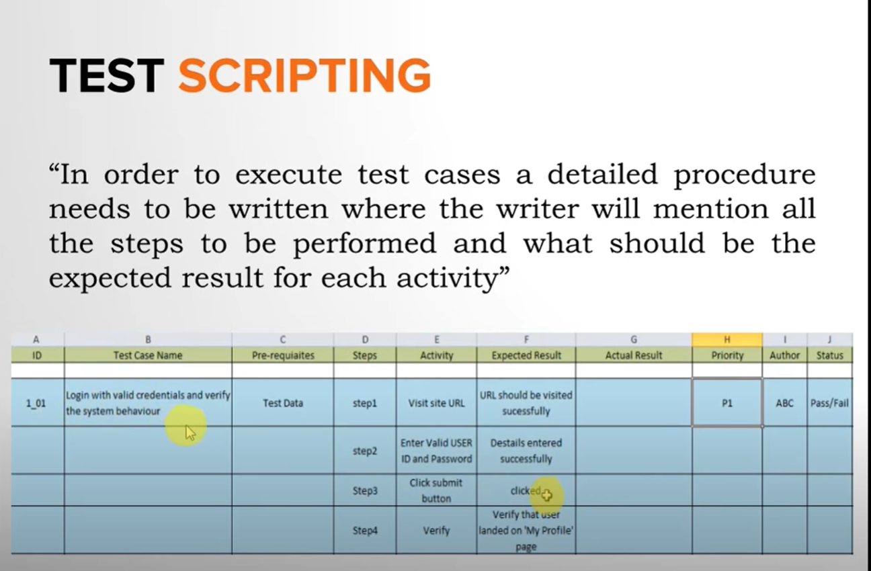

**Reference:** <https://www.youtube.com/watch?v=srqQvAZjL0Q&ab_channel=Test-O-Blog>